Lab 3 Report: Data Acquisition and Analysis of EOG Signals using Biosignalplux
Course: EEEE 536.60L1
Kinan Ghaalrebat

- Manifesto
Kinan(me) did all the report alone.
- Introduction
Electrooculography (EOG) is an electro physiologic method used to register the electrical signal produced by the movement of an eye. EOG possesses many application avenues in neurophysiology and biomedical engineering and human-computer interfaces. Recording, processing and analyzing EOG signals and the interest in decomposing and comparing some eye movements like vertical, horizontal, and blink signals are the issues to be addressed in this report. The aim is to identify facts regarding ocular muscle activity and uses of EOG signals in real environments.
- Theory
The human eye uses the corneo-retinal potential. The eye is itself a dipole with the cornea carrying a positive charge and retina carrying an opposite charge. As there is movement and rotation of the eye, there are electrical changes in the potentials around the eyes that are measurable. As there are electrodes put on the skin surrounding the eyes, one is able to measure the changes in the voltages and ascertain the direction and type of movement of the eye.
Horizontal Movement: To measure horizontal eye movements, two electrodes are located to the left and right of the eye. When moving to the left, the cornea is nearer to the left electrode and the reading on this side has greater voltage. Fixating to the right, the right electrode picks up an increased positive signal. The difference in the two potentials is used to define the direction and size of the horizontal movement.

Vertical Movement: Vertical movements are detected by electrodes located above and below an eye. Gazing upwards displaces the cornea toward the top electrode and increases its voltage. Looking down does the reverse to the bottom electrode. The top and bottom electrode voltages' difference in potential makes up the vertical eye movement.

Blink Detection: Blinks yield a sharp well-defined signal on the vertical EOG channel. A blink will cause an immediate and sudden change in the potential which reflects on the EOG signal in the form of high peak or spike. It is easy to identify these spikes on the basis of their form and size by just examining them.
- Methodology
1. Software
- OpenSignal Software through PLUX website.
- EOG.ipynb Jupyter notebook
2. Electrode Configuration
- Vertical EOG: This will have electrodes situated above and beneath the eye.
- The horizontal EOG: electrodes are positioned at the outer area and the inner area of the eye canthi.
3. Data Processing & Visualization
The software allowed data loading through both .txt and .h5 file formats:
- from numpy import loadtxt
- import biosignalsnotebooks as bsnb

- Results
For blinking:
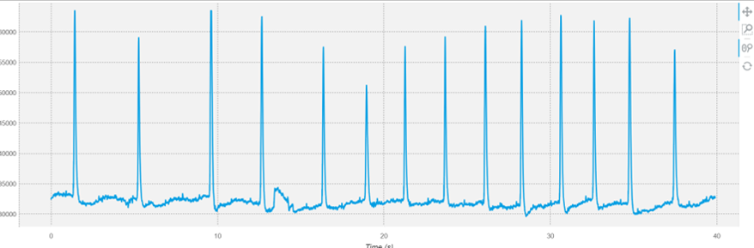
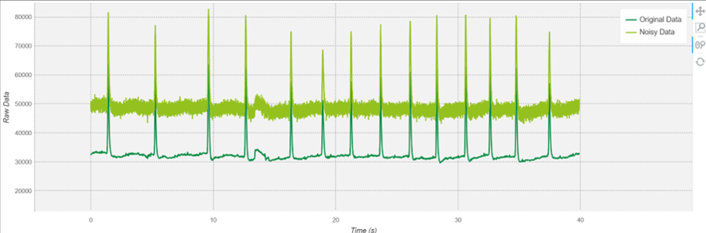

For Horizontal:

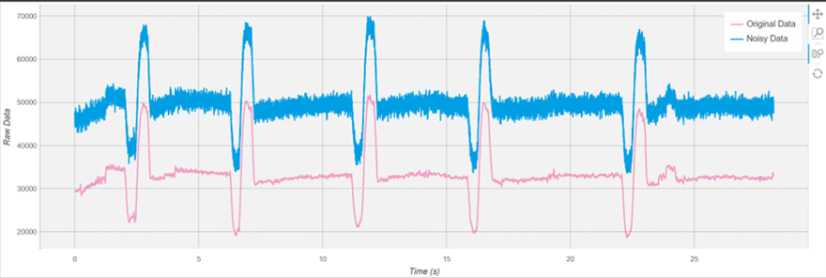

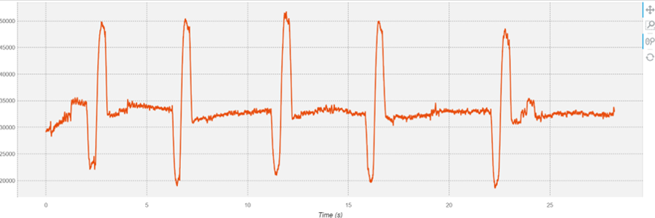

For Vertical:
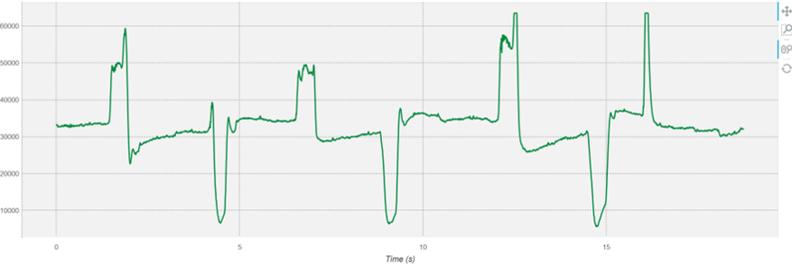

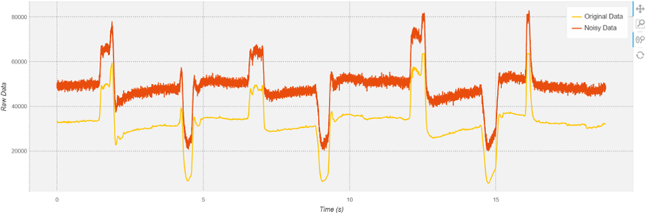

The plots of the EOG signal show clear differences among vertical, horizontal, and blinking activities. For horizontal eye movement, the signals have broader and smoother peaks with consistent rise and fall patterns that reflect the smooth left-right eye movements. The comparison of the two graphs (noisy and original) shows that horizontal movements are still evident even with moderate noise. for the vertical motion the signal contains steper and more distinct slopes that correspond to up-down movements of the eye. Vertical signals will also have larger amplitude changes than horizontal signals, which allows them to be distinguishable more easily. Blink detection, however, contains extremely sharp, high-amplitude spikes that are much shorter and more frequent than any other kind of movement. This inherent pattern makes blinks easily separable from the other eye movements, even in noisy conditions. The set of graphs by category confirms that noise does pollute signal clarity, but due to the distinctive patterns of each eye movement, they remain identifiable after basic filtering. In general, the graphs sufficiently separate the three types of motion according to waveform shape, amplitude, and frequency as major indicators.

EOG in real world applications:

EOG has various uses in daily life because it can accurately monater eye movement without invading the body. In the medical field, EOG is used commonly in the diagnosis of eye illnesses, such as retinitis pigmentosa and other retinal abnormalities. It is also used in sleep research to monitor rapid eye movement (REM) in different stages of sleep. In assistive technology, EOG is particularly important to the design of eye-controlled communication aids for severely handicapped people for controlling a computer or even verbal communication based on their eye movement. EOG is used in fatigue detection systems, especially in transport industries like air transport and long-distance trucking, where it can prevent accidents by monitoring a driver's alertness level. In neuroscience and science, EOG is used in cognitive load research, visual attention, and HCI through the study of patterns of eye movement. In general, EOG is an effective tool throughout healthcare, safety, and technology.

- Pictures of the EOG
